CURRICULUM VITAE

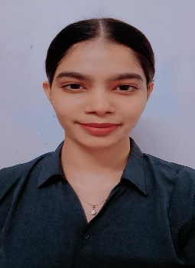
PERSONAL DETAILS

Name: Rakshani Ashok Chikhle
Date of Birth: 7th November 2000
Nationality: Indian
Contact number: +91 8928184983
Email: rakshanichikhle07@gmail.com
Address: Bhanji house, Yari road, Versova, 400061
Andheri West, Mumbai

OBJECTIVE:
To become an active member of a team in which leadership, teamwork, and creativity drives to deliver benefits to the company's goals and personal goals.

EDUCATION DETAILS:
Current Pursuing graduation from Sant Gadge Baba University

Feb 2018 Completed higher secondary from Bhagyashree College

March 2016 Secondary School from Holy Cross High School, Amravati.

WORK EXPERIENCE:

- Employer: Ashoka Hotel – Nagpur (Jan – April 2017)
Job Title: Receptionist
Responsibilities:
4 months experience as a dual role of Receptionist plus handling guest check-ins and check-out along with guest relationship management.

- Employer: Vastusankalp Group – Mumbai (June 2017-December 2017).
Job Title: Property Consultant
Responsibilities:
I was responsible for tele-calling and helping people to buy, sell and rent land and properties. Each day was spent on both active, income-producing work and on the extensive administrative paperwork that the job entails.

- Employer: Morpheus Consultancy – Mumbai (Jan – April 2019)

Job Title: HR Consultant/Recruiter
Responsibilities:
I was responsible to Design and implement overall recruiting strategy, develop and update Job Descriptions and recruit candidates and post jobs to appropriate job board/newspapers/colleges etc.

PERSONAL STRENGTHS:
- Excellent communications skills
- Team player
- Work with people at all levels
- Organised and efficient
- Proactive, Punctual, Responsible, Quick Learner

HOBBIES:

- Travelling and exploring new places
- Photography
- Writing
- Cooking
- Music

LANGUAGES KNOWN:

- English
- Hindi
- Marathi

